- Purpose
  - The purpose of this document is to describe the procedure for assembling an Orbital Strip Machine.
- Scope
  - This SOP applies to all equipment assembly team members. The process applies to the following machine ID’s:
E012801EQM0600BA1000 – Basic Sand Dragon, 20”
E012801EQM0607BE1200 – Crewman ORB 20
E012801EQM0607BA1200 – Basic Sand Dragon 20, Canadian
E012801EQM0607BE1200 – Crewman ORB 20, Canadian
E012806EQM0600BA1000 – Basic Sand Dragon, 20”, w/ Weights
E012806EQM0600BE1200 – Crewman ORB 20, w/Weights
E012806EQM0607BA1200 – Basic Sand Dragon 20, w/Weights, Canadian
E012806EQM0600BE1200 – Crewman ORB 20, w/Weights, Canadian
E012811EQM0600BA1000 – Basic Sand Dragon, 28”, w/Weights
E012811EQM0600BE1000 – Crewman 28 ORB, w/Weights
E012811EQM0607BA1200 – Basic Sand Dragon 28, w/Weights, Canadian
E012811EQM0607BE1200 – Crewman ORB 28, w/Weights Canadian
- Responsibilities
  - The operations manager/supervisor is responsible for enforcing this SOP.
- Materials
  - The proper materials needed for this process are listed on the machine work order.
  - Hand/Power Tools
- Definitions

- Procedure
  - Place a motor (89675) onto the table in the orientation shown. The capacitors should face the edge of the table. Leave the bag under it to prevent scratching the motor.

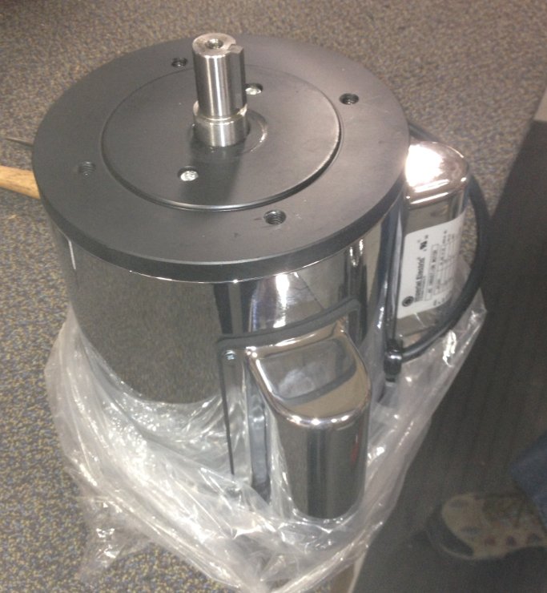
  - Place the machine base onto the motor in the orientation shown. The wheels face the same way as the capacitors on the motor. Line the holes in the motor with the holes in the base. Ensure the base sits flush. Refer to SOP EQ 084 for base assembly instructions.

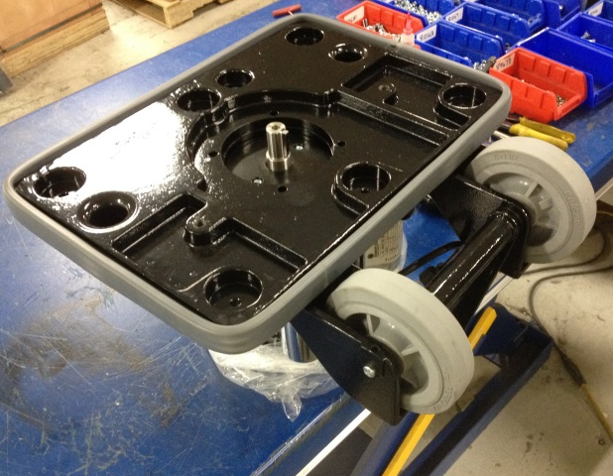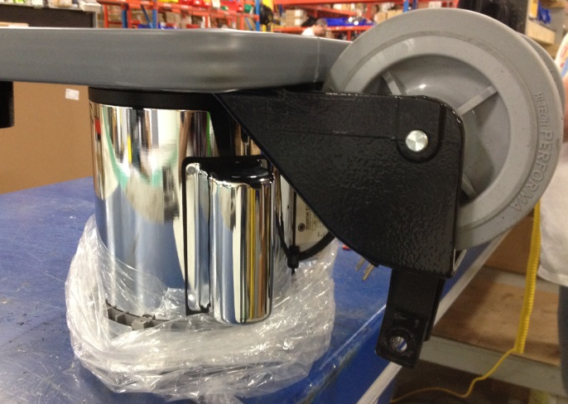

  - Attach the base to the motor using 4 bolts (81087) with 4 lock washers (81066). Put blue Loctite onto the threads prior to assembly.

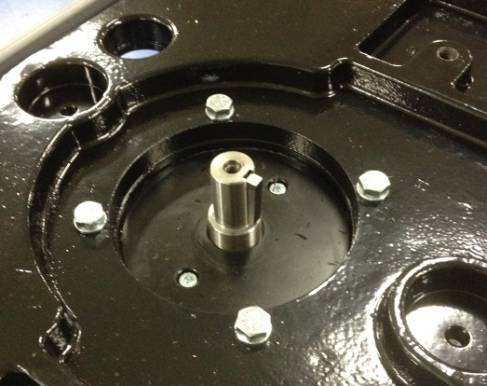

  - Place an eccentric (SOP EQ 086) over the motor shaft. Ensure the key lines up. A rubber mallet may need to be used to get it all the way on.

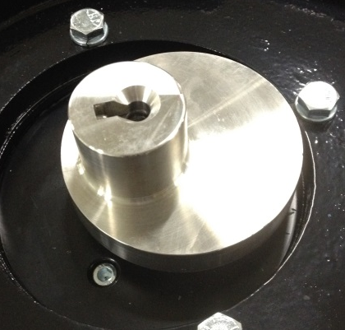
  - Use a flat head screw (89683) to secure the eccentric to the motor shaft. Use red Loctite on the threads of the screw.

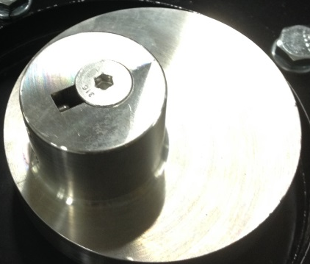

  - Install 2 set screws (89678) into the threaded hole on the eccentric. This holds the key in place. Use blue Loctite on the threads. Stacking 2 sets screws helps lock them in place.

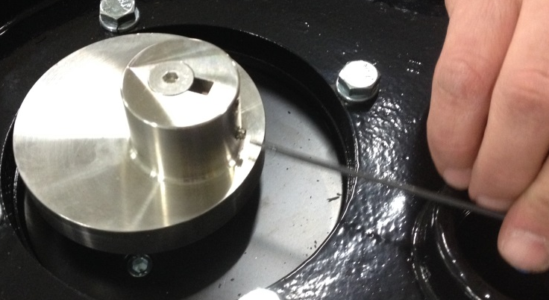

  - Place a nylon washer (89835) into all of the pockets shown on the base. A 20” machine has 6 pockets and a 28” machine has 8.

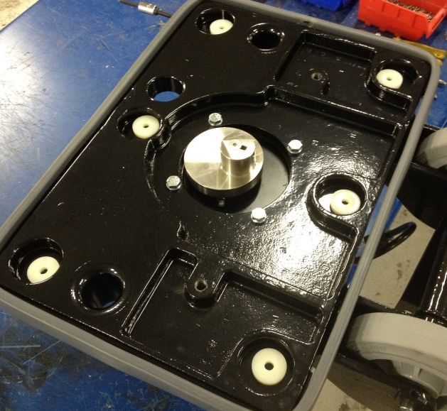
  - Assemble a pad plate (SOP EQ 085) to the base. The threaded stems on the dampeners pass through the nylon washer and then through the base. The bearing will also install over the eccentric. Ensure that the brass fitting on the plate is in the proper orientation. It needs to pass the hole shown on the base.

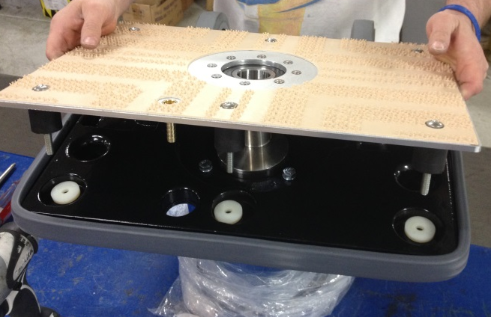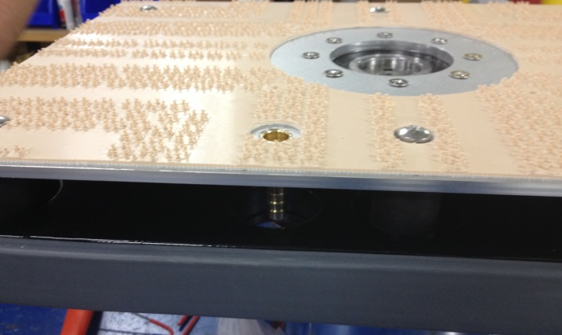

  - On the opposite side of the base use a nut (81063), a lock washer (81067), and a flat washer (81062) to secure each threaded stem. There are 6 locations on a 20” machine and 8 locations on a 28”.

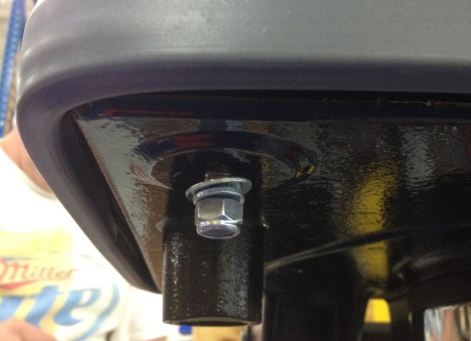

  - Take a center piece that was provided with the flex lock pad and place it over the end of the motor as shown. You will need to trim to OD of the piece to get it to fit. Peel the back off and stick it into place.

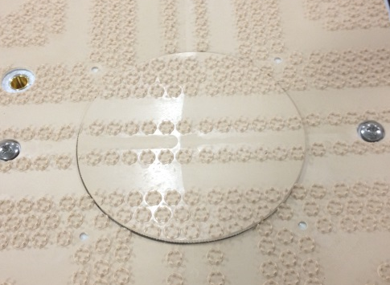
  - Place a red floor pad onto the flex lock. Use 89831 for a 20” machine or 89832 for a 28” machine.

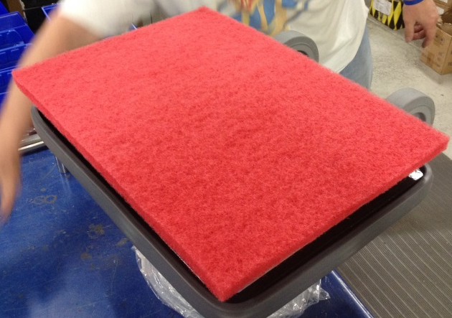

  - Flip the machine over so that it is sitting on the red pad.

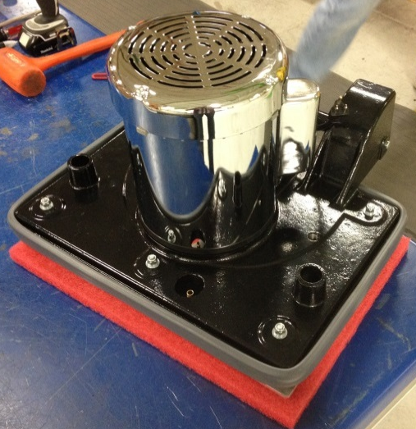

  - Place the appropriate decal onto the front of the motor. Use 83773 for a Betco machine or 83728 for a Basic machine.

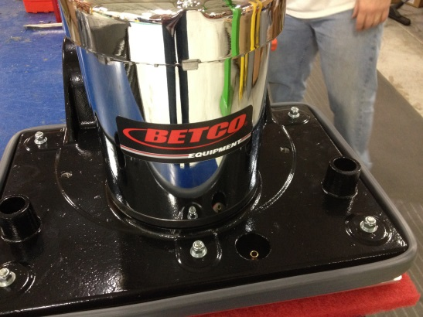
  - There are 2 tapped holes on the handle support areas that may need to be tapped out prior to assembly. They may have paint or debris in them.

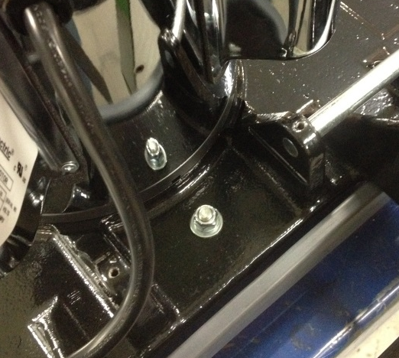

  - Take a handle axle (89676) and place it into one side of the support as shown.

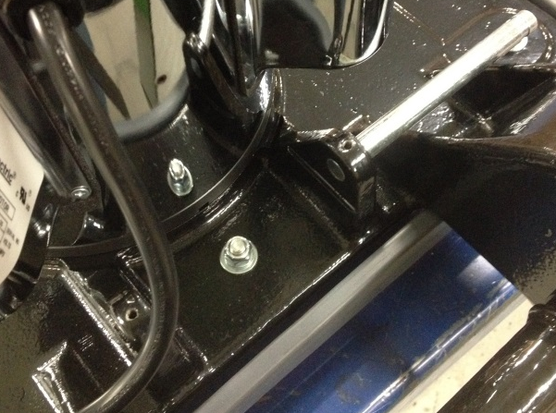

  - Take an assembled handle (SOP EQ 066) and place the appropriate decal onto the front of it. (Use 89771 for a Betco 20”, 89773 for a Basic 20”, 89772 for a Betco 28”, or 89774 for a Basic 28”)

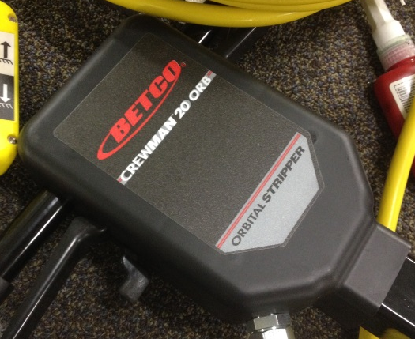
  - Place a step bushing (89669) into each end of the tube at the bottom of the handle.

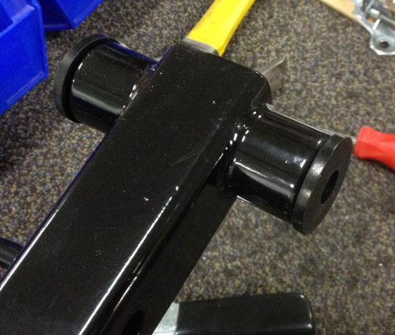

  - Put the handle into place on the machine. Ensure that it is oriented properly. Push the handle axle through the handle and through the opposite support. Center the axle.

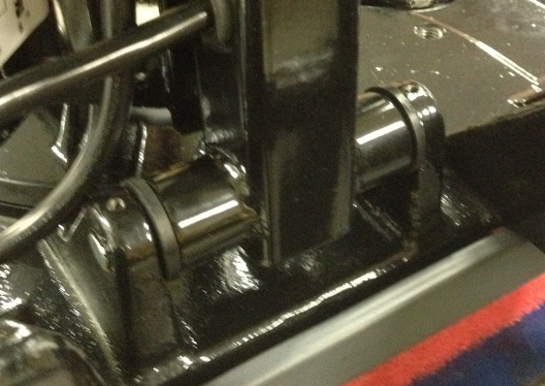

  - Install 2 set screws into the threaded holes on each end of the axle. Use blue Loctite on the threads.

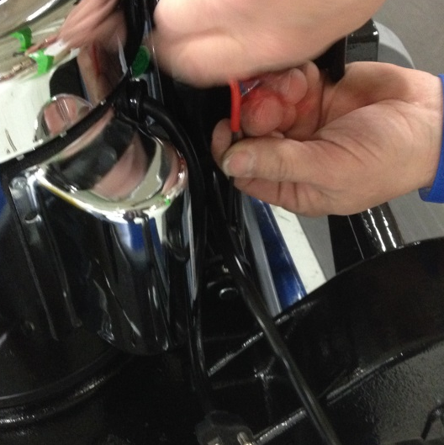
  - Connect the plug from the handle to the motor.

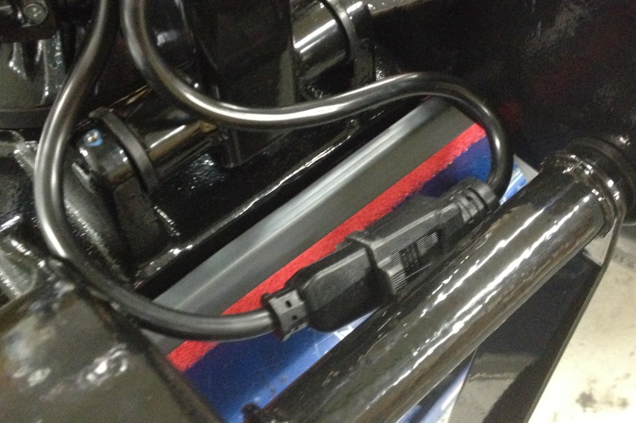

  - Fasten the cam lock bar (89671) and the cam lock slide bar (89670) to the handle using 2 bolts (89681), 2 flat washers (81713), and 2 lock nuts (83520). Note the orientation of the bars.

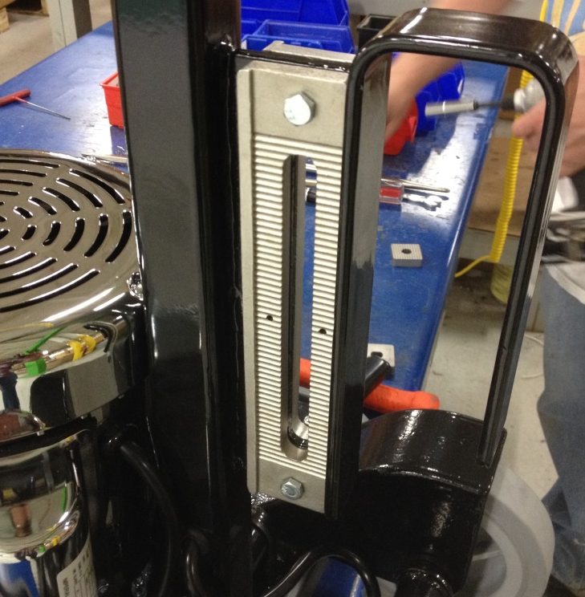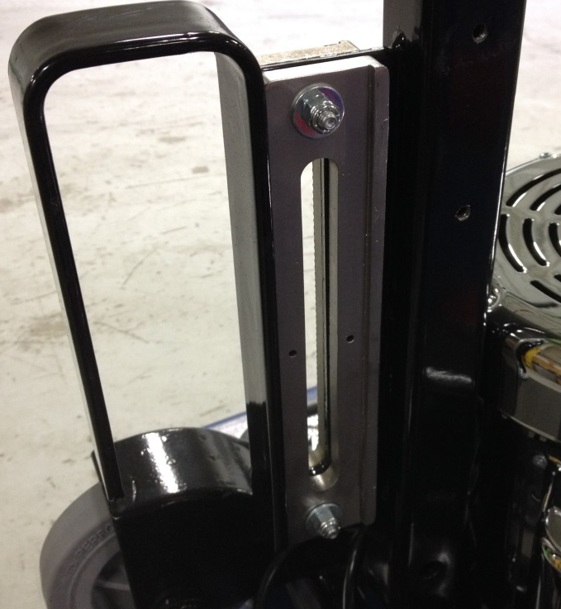

  - Locate a cam lock handle. Refer to SOP EQ 082 for assembly instructions.

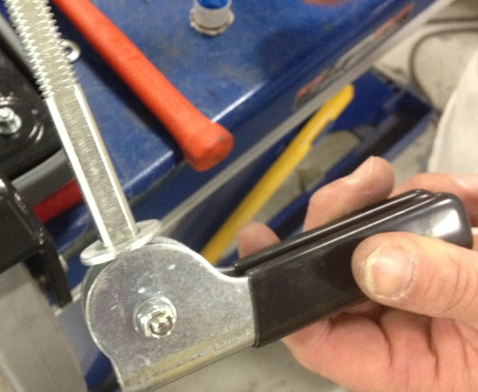

  - Place a flat washer (12407) over the shaft of the cam handle. Rotate the arms of the handle weldment up so that they are over the slide bars. Place a cam lock foot (89660) between the cam lock bar and the weldment. Ensure that the grooves on the foot line up with the grooves on the lock bar. Feed the cam handle through the weldment arm and the foot.

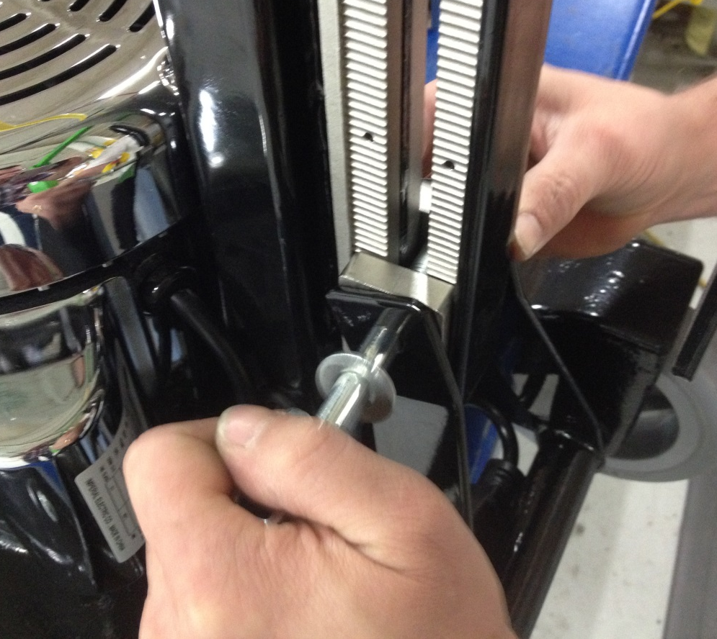
Weldment
Lock Foot

  - On the opposite side, place a cam slider foot (89661) between the slider bar and the weldment. Pass the end of the cam lock handle through the foot and the weldment arm. Put a flat washer (12407) over the threaded end of the cam lock shaft and then use a lock nut (12410) to secure the entire assembly.

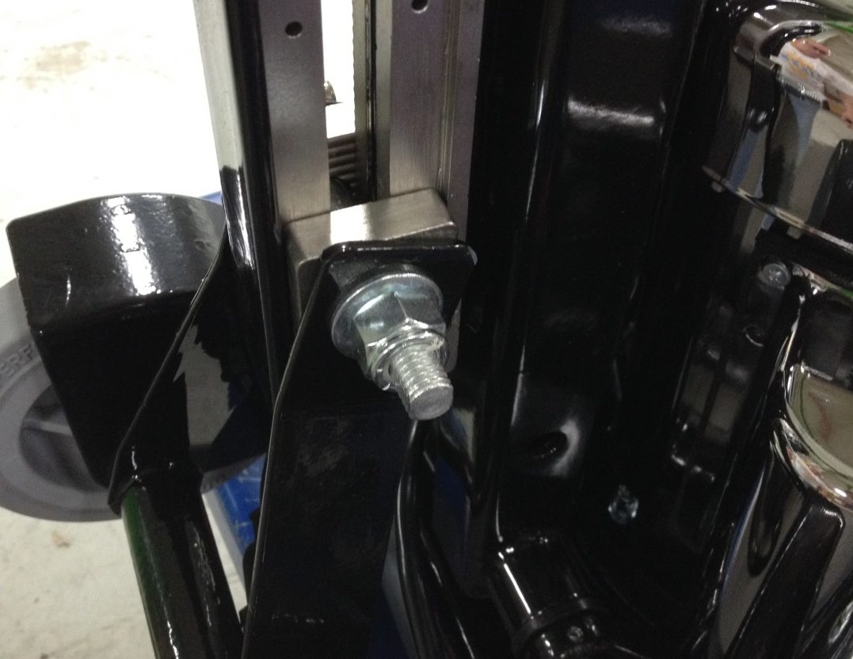
Weldment
Slide Foot

  - Tighten the lock nut enough so that the cam handle properly locks the machine handle in place.

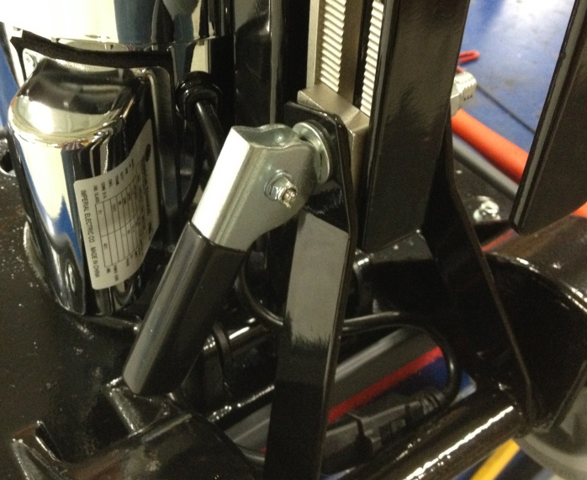
  - If a machine without weights is being assembled, assembly is complete. If the machine needs weights, proceed from this point.
  - The machine takes a total of 4 weights. Use 89706 for a 20” machine or 89707 for a 28” machine. Place 2 weights onto each side of the machine.

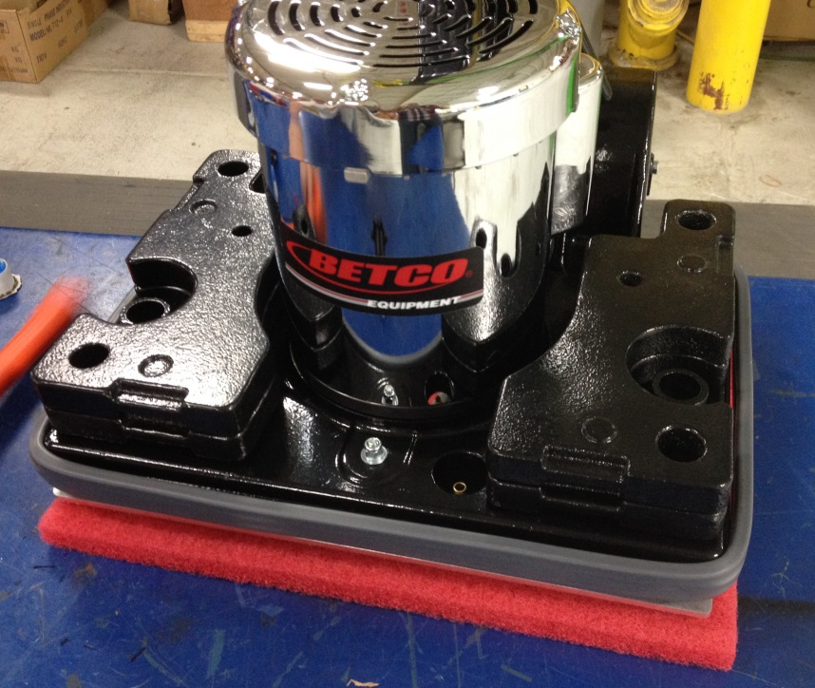

  - Secure each stack of weights with a knob (SOP EQ 081). The threaded end of the knob simply threads into the base. Ensure the pins on the knob rest in the recessed slots, not the through slots.

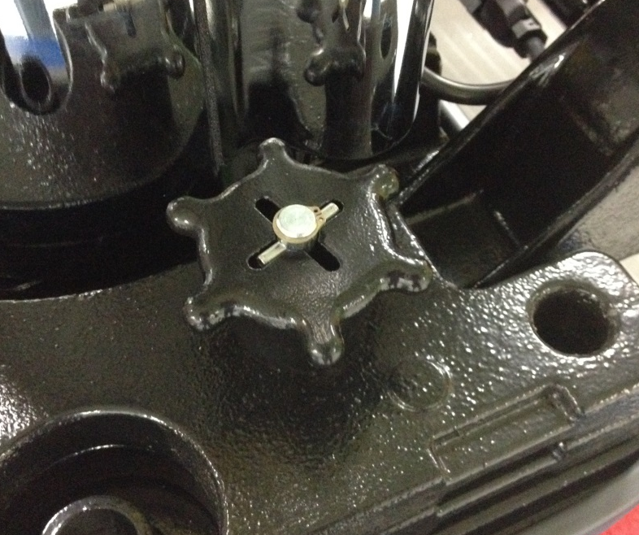

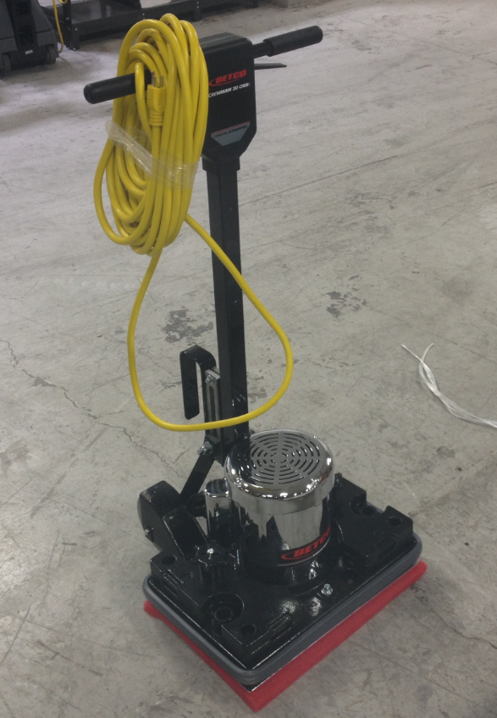

- References (optional section as needed)

- Training Guide

Functional Training Groups Requiring Training
Equipment Assembly Group

- SOP Change Control

Date of Change | Reason for Change
4/28/2018 | This is the first version of the S.O.P. hence there are no revisions to this document.
1/16/2018 | Added the Responsibilities Section and some other small updates.
10/15/2024 | Updated Machine ID’s

Approvals

Submitter/Author Approval:__________________________________ Date:______________________

Management Approval:______________________________________ Date:______________________

QAU Approval:_____________________________________________ Date:______________________

